**HOWLAND MAT CATS WRESTLING**

**SIGN-UP FORM**

Wrestler’s Name: ______________________________________________________________________

Birth Date: ____/____/____ Grade: _______ Age: _______ School: ______________________­­­______

Home Address: ________________________________________________________________________

City: ________________________________________________ State: _________ Zip: ______________

Home Phone: (_____) _________________ Email Address: _____________________________________

Parent/Guardian: ___________________________________ Cell Phone: (____) ___________________

Parent/Guardian: ___________________________________ Cell Phone: (____) ___________________

*\*Coaches will send updates and reminders via Remind Me (text # 81010 and message @howlandmc to join). Check the website weekly for schedules, forms, etc. at howlandmatcats.com.*

Wrestling Experience: _______________________________Approximate Weight: _________________

Other Sport Involvement: _______________________________________________________________

_____________________________________________________________________________________

Additional Information Regarding Wrestler (for coaches): ______________________________________

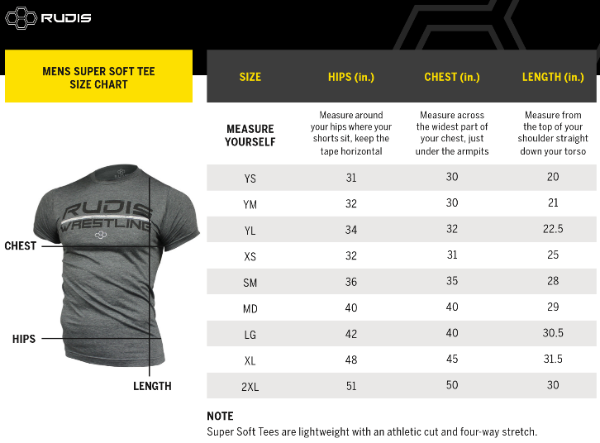_______________________________________________

T-Shirt Size: YSM YMD YLG

AXS ASM AMD ALG AXL A2XL

*(Program cost includes a t-shirt. Circle size.)*

*Please complete both sides of this form.*

--OFFICE USE ONLY—

**Payment Information: CASH____________ CHECK #______________ Additional Rudis Gear _________**

**(Payable to Howland Tiny Tigers Wrestling Club)**

|  |  |  |  |
| --- | --- | --- | --- |
| **Equipment** | **Issue Date** | **Return Date** | **Rudis Order Info** |
| Singlet Size |  |  |  |
| Headgear |  |  |  |
| Shoe Size |  |  |  |

**HOWLAND MAT CATS PERMISSION SLIP AND EMERGENCY MEDICAL AUTHORIZATION**

Student’s Name____________________________________________________________________________________ Address_______________________________________________ Phone: (_____) ______________________________

*Please list the telephone number(s) to reach a parent/guardian during the time of this program: _________________________________________________________________________________________________

I/We hereby give permission to (wrestler) ________________________________________ to participate in the following activity/program ______________________________________, as described on (date) ____/____/_______. I/We shall not hold the school authorities liable for any injury incurred as a result of this activity/program.

DATE __________________ SIGNATURE OF PARENT/GUARDIAN____________________________________________

*Purpose: To enable parents and guardians to authorize the provision of emergency treatment for children who become ill or injured while under school authority, when parents or guardians cannot be reached.*

(PART I **OR** II MUST BE COMPLETED)

PART I TO *GRANT CONSENT****:***

In the event reasonable attempts to contact me during this activity/program at (home or cell numbers) ____________________________________________________ or other parent or guardian at (home or cell numbers) _______________________________________________ have been unsuccessful, I hereby give my consent for: (1) administration of any treatment deemed necessary by (preferred physician) Dr._______________________________________ or (preferred dentist) Dr.__________________________________, or in the event the designated preferred practitioner is not available, by another licensed physician or dentist; and (2) the transfer of child to _________________________________________________ (preferred hospital) or any hospital reasonably accessible.

This authorization does not cover major surgery unless the medical opinions of two other licensed physicians or dentists, concurring in the necessity for such surgery, are obtained prior to the performance of such surgery. List any health condition, such as heart disease, diabetes, epilepsy, severe allergies, eye or ear problems or chronic conditions, etc. List any prescribed medication that your child is taking: CONDITION(s):_____________________________________________________________________________________ MEDICATION(s):___________________________________________________________________________________

DATE __________________ SIGNATURE OF PARENT/GUARDIAN____________________________________________

Part II *REFUSAL TO CONSENT*:

I do not give my consent for emergency medical treatment of my child. In the event of illness or injury requiring emergency treatment, I wish the school authorities to take no action or to:__________________________________________________________________________________________.

List any health condition, such as heart disease, diabetes, epilepsy, severe allergies, eye or ear problems or chronic conditions, etc. List any prescribed medication that your child is taking: CONDITION(s):_____________________________________________________________________________________ MEDICATION(s):___________________________________________________________________________________

DATE __________________ SIGNATURE OF PARENT/GUARDIAN____________________________________________